**Enterprise Resource Planning**

**Training User Manual**

**VERSION 12.0.0**

**Table Of Contents**

|  |  |
| --- | --- |
| Name of Content | Page No. |
| 1. introduction to THE ERP SYSTEM    1. Getting started with the interface    2. Login    3. Select Business    4. Modules    5. Change Password |  |

**The Modules**

|  |  |
| --- | --- |
| Name of Content | Page No. |
| 1. **Administration**    1. [Master Setup](javascript:run1()&menuname=cacodes)    2. [System Administration](javascript:run1()&menuname=Setup)    3. ZABDB Backup |  |
| 1. **Approval System** |  |
| 1. **General Accounts** |  |
| 1. **Management** |  |
| 1. **Purchase** |  |
| 1. **Sales & Invoicing**    1. [Invoice Entry](http://192.168.1.17:8090/zab/login?screen=opdoheader&option=Invoice+Entry&menuname=op)    2. [Sales Return](http://192.168.1.17:8090/zab/login?screen=opcrnheader&option=Sales+Return&menuname=op)    3. [Money Receipts and Allocation](http://192.168.1.17:8090/zab/login?screen=arcas&option=Money+Receipts+and+Allocation&menuname=op)    4. [Money Refund to Client](http://192.168.1.17:8090/zab/login?screen=arpayment&option=Money+Refund+to+Client&menuname=op)    5. [Transfer To AR](http://192.168.1.17:8090/zab/login?screen=opdoheaderar&option=Transfer+To+AR&menuname=op)    6. [Reports](javascript:run1()&menuname=opreports) |  |
| 1. **Inventory**    1. [Create GRN (Direct)](http://192.168.1.17:8090/zab/login?screen=pogrndirect&option=Create+GRN+%28Direct%29&menuname=im)    2. [Receive Entry](http://192.168.1.17:8090/zab/login?screen=imtrnre&option=Receive+Entry&menuname=im)    3. [Transfer and Receive](http://192.168.1.17:8090/zab/login?screen=imtorheader&option=Transfer+And+Receive&menuname=im)    4. [Reports](javascript:run1()&menuname=imreports) |  |
| 1. **Reports** |  |
| 1. **Searching Option** |  |

# introduction to THE ERP SYSTEM

## Getting started with the interface

This Training Manual provides a complete overview of all processes within the Enterprise Resource Planning(ERP) system, the functionalities of the software and how to navigate in the menu and forms.

## login

All users need to login to start using the ERP system. After login the ERP system opens for selecting your desired business.

LOGIN

|  |  |
| --- | --- |
| **Step 1** | Open internet Explorer |
| **Step 2** | Go to <http://182.160.99.210:8080/zab/login> (182.160.99.210 = IP) |
| **Step 3** | Bookmark this site for later use |
| **Result** | Insert your ‘User ID’ & ‘Password’ to login. |

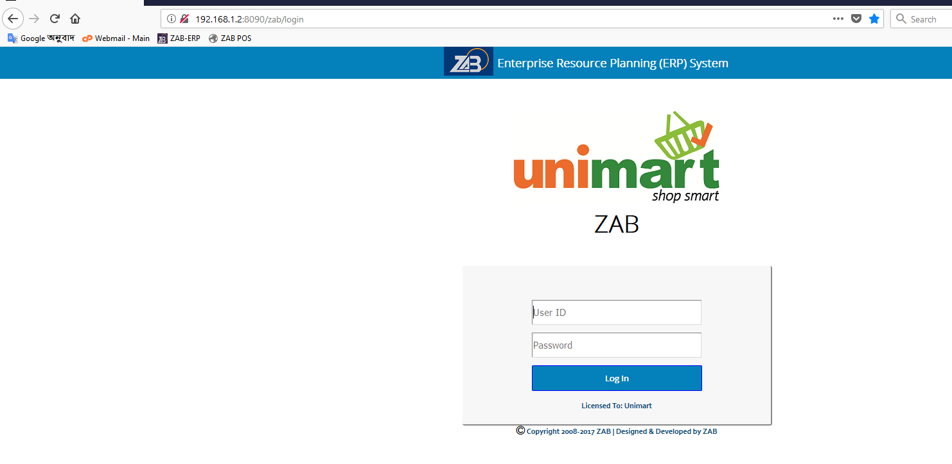

## Select business

After logging in, All users need to select their desired business to start using the ERP system. After selecting the ERP system opens all features that are assigned to the user.

|  |  |
| --- | --- |
| **Step 1** | Select your desired business |
| **Step 2** | Press on home icon to access the modules (options). |

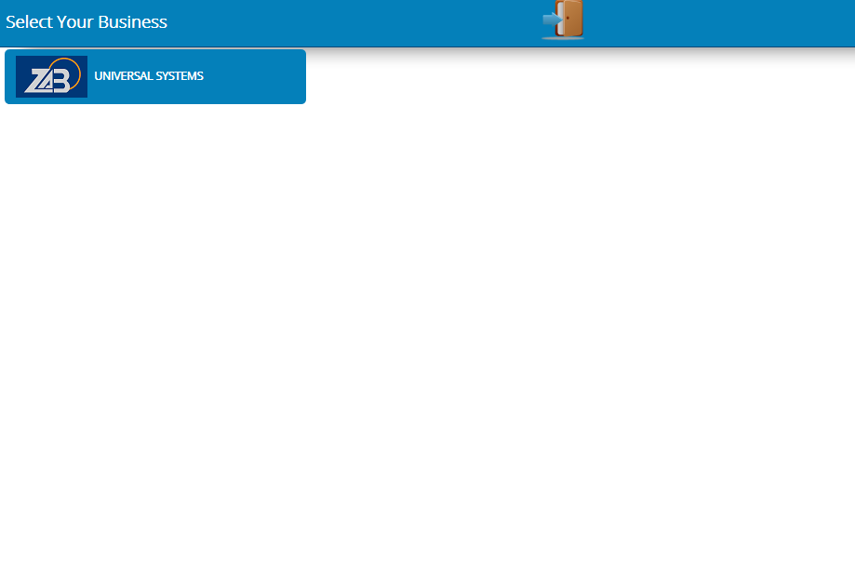

## Modules (Options)

* **Administration**
* **Approval System**
* **General Accounts**
* **Management**
* **Purchase**
* **Sales & Invoicing**
* **Inventory**
* **Reports**
* **Searching Option**

## Change Password

# store Requisition (SR)

## SR Header

|  |  |
| --- | --- |
| **Step 1** | Open System **>** Requisition **>** Store Requisition |
| **Step 2** | Select date, Department name, Shift and Justification |
| **Step 3** | Click Add |
| **Step 4** | Click Detail for selecting Product for SR |
| **Result** | New SR header created |

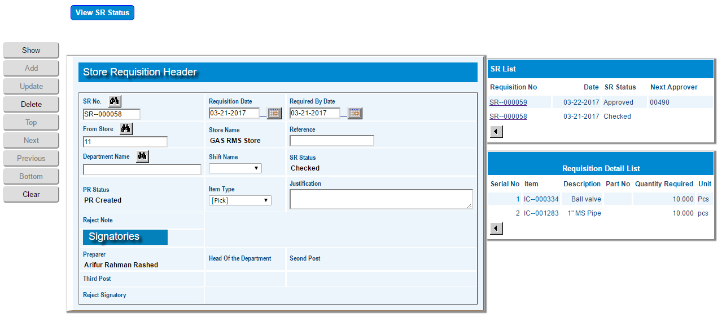

## SR Detail

|  |  |
| --- | --- |
| **Step 1** | Open System **>** Requisition **>** Store Requisition |
| **Step 2** | Click Detail |
| **Step 3** | Select Product code, Required Quantity |
| **Step 4** | Click Add |
| **Step 5** | Repeat Step 1 to 3 for adding multiple products |
| **Step 6** | Click **Return** to return to SR header |
| **Step 7** | Click **View SR Status** for preview |
| **Step 8** | Click **Confirm** to confirm the SR. An email will be automatically send to the Approval authority. |
| **Note** | SR cannot be changed after confirmation. |
| **Result** | SR creation complete |

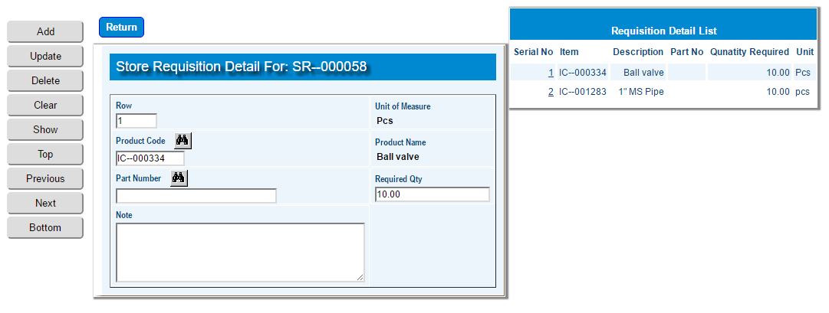

# receive from store

|  |  |
| --- | --- |
| **Step 1** | Open System **>** Requisition **>** [Received from Store](http://localhost:8080/zab/login?screen=moreqheaderrc&option=Received+from+Store) |
| **Step 2** | Select Store Requisition (SR) no. |
| **Step 3** | Click Receive |
| **Step 4** | Click **Print Received Challan** for preview in print format. |
| **Result** | Requested product received. |

# 

## Product Return Detail

|  |  |
| --- | --- |
| **Step 1** | Open System **>** [Requisition **>** [Product Return Entry](http://localhost:8080/zab/login?screen=imrrheader&option=Product+Return+Entry)](http://localhost:8080/zab/login?screen=moreqheaderrc&option=Received+from+Store) |
| **Step 2** | Select PR from side list or write the no in the Requisition no field |
| **Step 3** | Click Show |
| **Step 4** | Click Detail for selecting Product for return |
| **Result** | Product return header created |

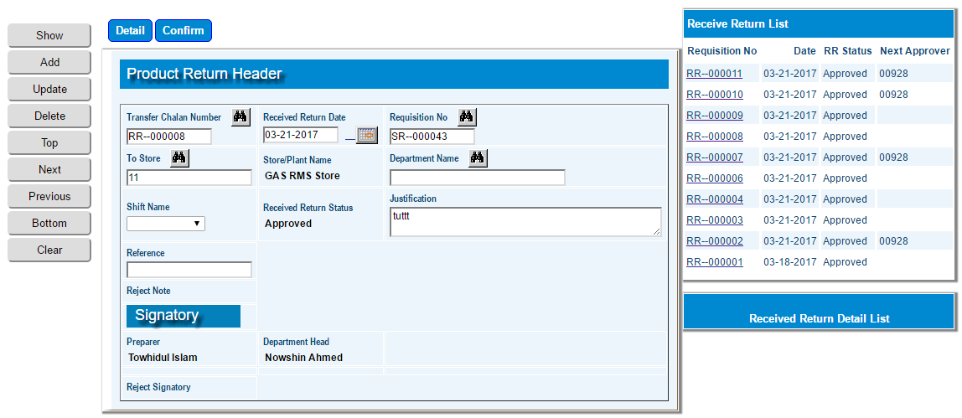

# product return detail

|  |  |
| --- | --- |
| **Step 1** | Open System **>** Requisition **>** Store Requisition |
| **Step 2** | Click Detail |
| **Step 3** | Select Product code, Required Quantity |
| **Step 4** | Click Add |
| **Step 5** | Repeat Step 1 to 3 for adding multiple products |
| **Step 6** | Click **Return** to return to SR header |
| **Step 7** | Click **View SR Status** for preview |
| **Step 8** | Click **Confirm** to confirm the SR. An email will be automatically send to the Approval authority. |
| **Note** | SR cannot be changed after confirmation. |
| **Result** | SR creation complete |

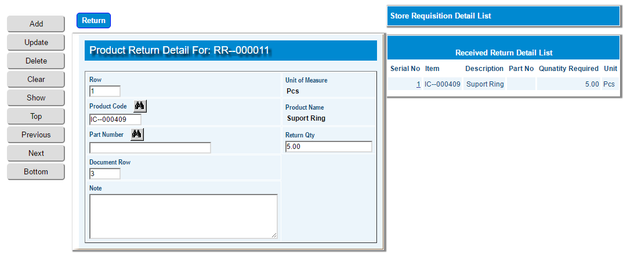

# issue from store against SR

## Check stock availability

|  |  |
| --- | --- |
| **Step 1** | Open System **>** Inventory **>** [Requisition **>** Issue from store](http://localhost:8080/zab/login?screen=moreqheaderrc&option=Received+from+Store) |
| **Step 2** | Select SR from side list or write the no in the Requisition no field |
| **Step 3** | Click show |
| **Step 4** | Click **Check Stock** |
| **Result** | Requested product checked for availability and will show the stock status in the bottom list. |

## Issue from stock

|  |  |
| --- | --- |
| **Step 1** | Open System **>** Inventory **>** [Requisition **>** Issue from store](http://localhost:8080/zab/login?screen=moreqheaderrc&option=Received+from+Store) |
| **Step 2** | Select SR from side list or write the no in the Requisition no field |
| **Step 3** | Click show |
| **Step 4** | Click **Issue From Stock** |
| **Result** | Requested product issued to the requester. |

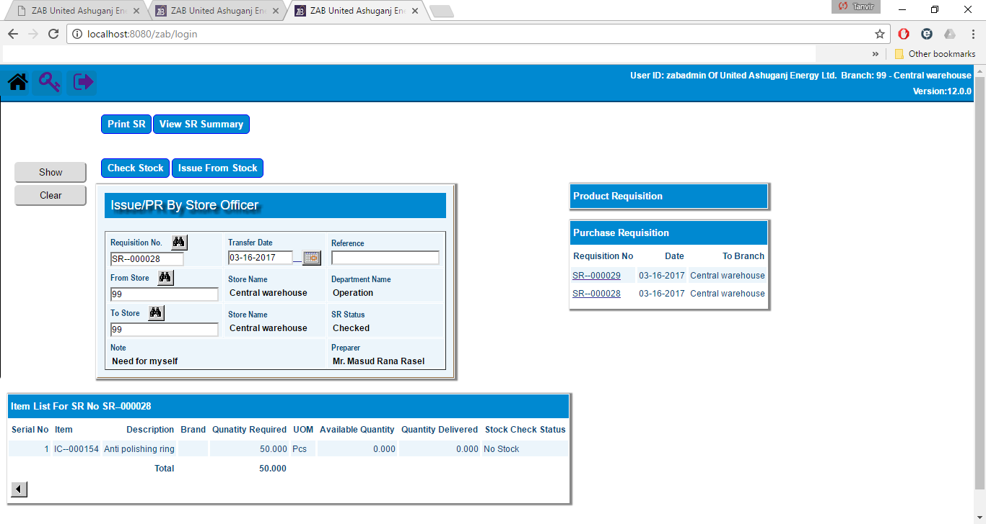

# create purchase requisition (PR)

|  |  |
| --- | --- |
| **Step 1** | Open System **>** Inventory **>** [Requisition **>** [Direct PR from SR](http://localhost:8080/zab/login?screen=imtormoreqheaderprdir&option=Direct+PR+from+SR)](http://localhost:8080/zab/login?screen=moreqheaderrc&option=Received+from+Store) |
| **Step 2** | Select SR from side list or write the no in the Requisition no field |
| **Step 3** | Click show |
| **Step 4** | Click **Create PR** |
| **Result** | PR created and the PR no will show in the Purchase Requisition side list. |

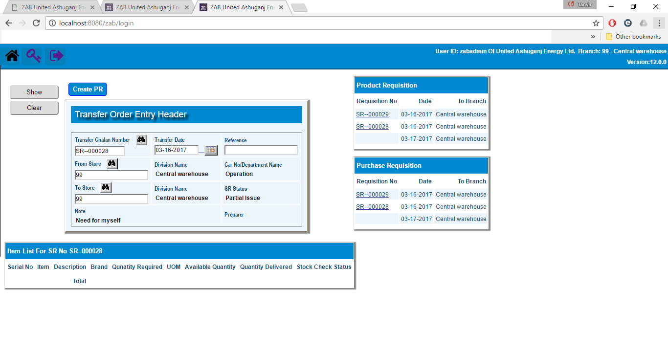

# create goods receipt note (GRN)

## Create Full GRN

|  |  |
| --- | --- |
| **Step 1** | Open System **>** Inventory **>** Create GRN |
| **Step 2** | Select PO no from side list or write the no in the PO no field |
| **Step 3** | Click show |
| **Step 4** | Click **Create GRN** |
| **Step 5** | Click on the GRN no from the bottom side list that just created |
| **Step 6** | Select store and write the vendor challan no. |
| **Step 7** | Click Update |
| **Step 8** | Click Confirm |
| **Step 9** | Click **Print GRN** to preview GRN in Print format |
| **Result** | GRN will be confirmed. |

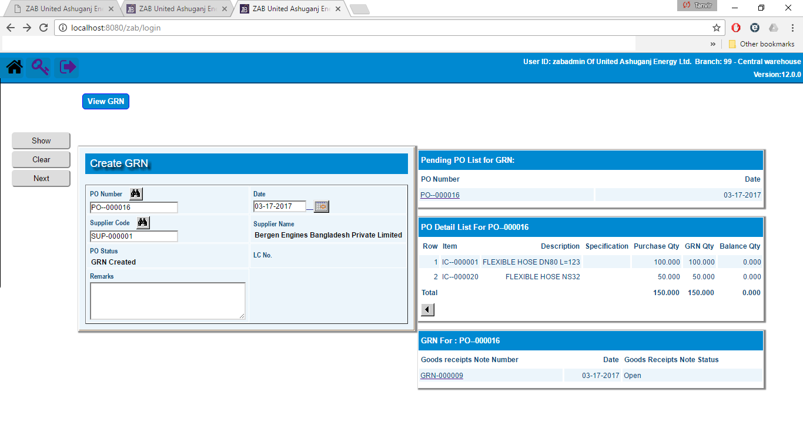

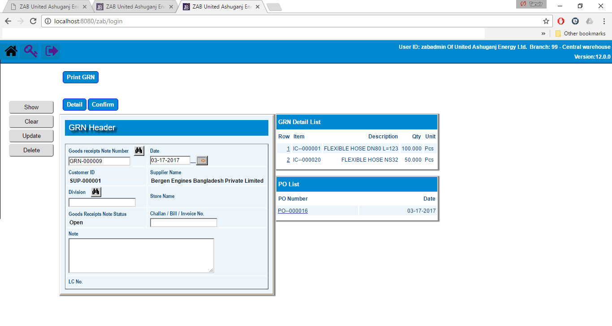

## Create Partial GRN

|  |  |
| --- | --- |
| **Step 1** | Follow step 1 to 7 of full GRN process |
| **Step 2** | Click Detail |
| **Step 3** | Select the item from side list for receiving partially |
| **Step 4** | Click Update |
| **Step 5** | Click Return when complete |
| **Step 6** | Click Confirm |
| **Result** | GRN will be confirmed. |

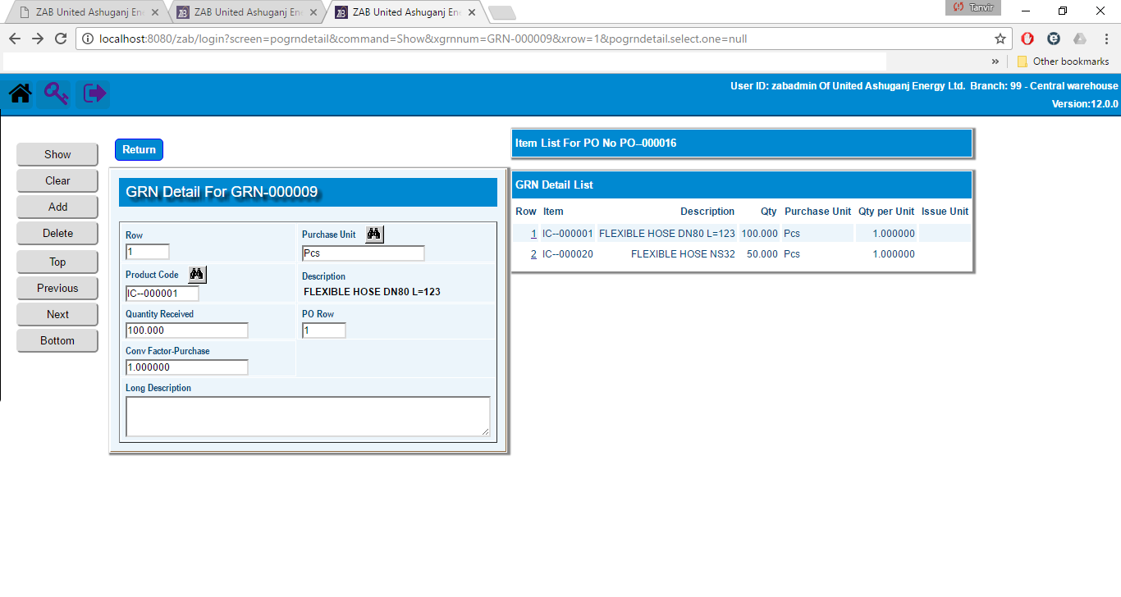

# create purchase requisition (PR)

|  |  |
| --- | --- |
| **Step 1** | Open System **>** Purchase **>** Create PR |
| **Step 2** | Select SR from side list or write the no in the SR no field |
| **Step 3** | Click show |
| **Step 4** | Click **Create PR** |
| **Result** | PR will be created and shown on the bottom side list. |

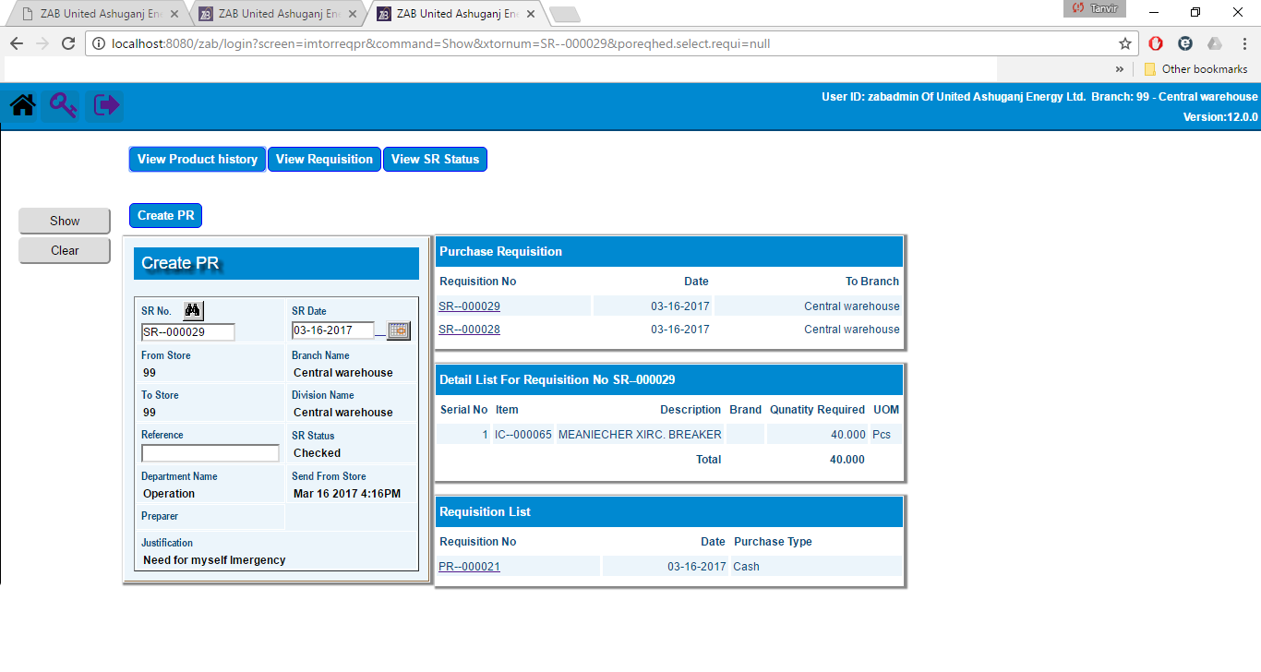

# selecting PR type: (cash/agreement/Cs/LC)

|  |  |
| --- | --- |
| **Step 1** | Follow Step 1 to 3 |
| **Step 2** | Click on the desired PR no from the side list |
| **Step 3** | Select Purchase Type Cash/Agreement/CS/LC |
| **Step 4** | Click Update |
| **Step 5** | Click Detail |
| **Step 6** | Select the desired item by clicking on the item code from the **Store Requisition Detail** side list |
| **Step 7** | Click Add |
| **Step 7** | Repeat Step 6 and 7 for adding multiple products |
| **Step 8** | Click Complete when done |
| **Result** | Cash PR created |

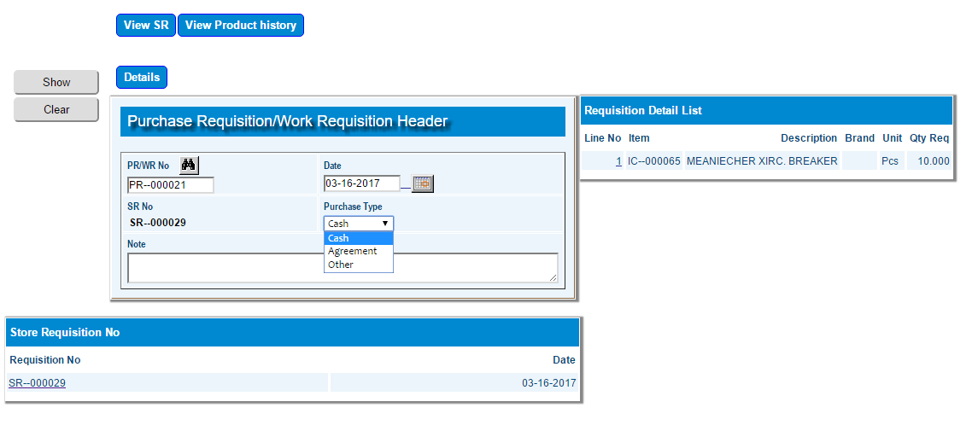

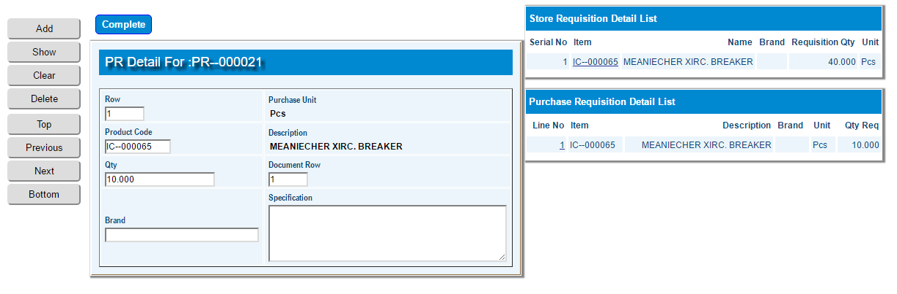

# Create estimated cost for cash purchase

|  |  |
| --- | --- |
| **Step 1** | Open System **>** Purchase **>** [Create estimated cost(Cash Purchase)](http://localhost:8080/zab/login?screen=poreqheadercash&option=Create+estimated+cost%28Cash+Purchase%29) |
| **Step 2** | Select PR from side list or write the no in the PR no field |
| **Step 3** | Click show |
| **Step 4** | Click Detail |
| **Step 6** | Select the desired item by clicking on the product code from the **PR Detail** side list |
| **Step 7** | Fill in Purchase Price |
| **Step 8** | Click Update |
| **Step 9** | Repeat Step 6 to 8 for adding multiple products |
| **Step 10** | Click Return when done |
| **Result** | Created for estimated cost for Cash Purchase |

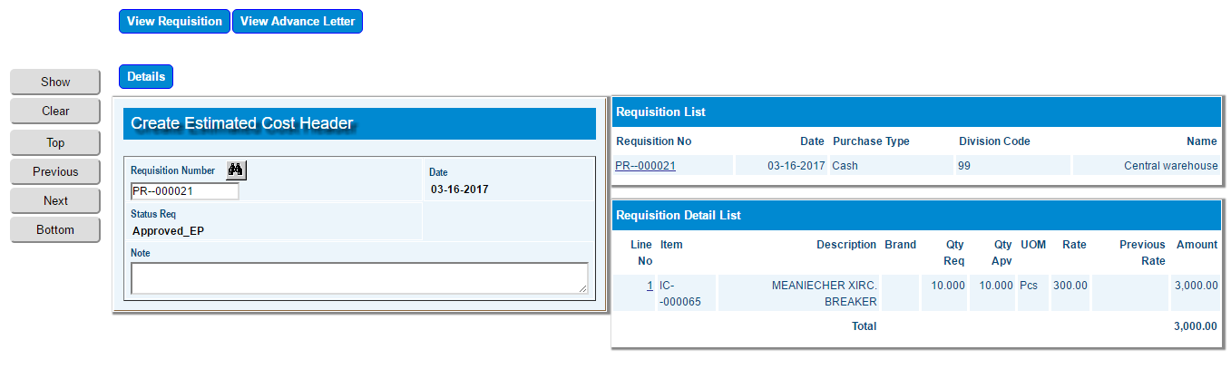

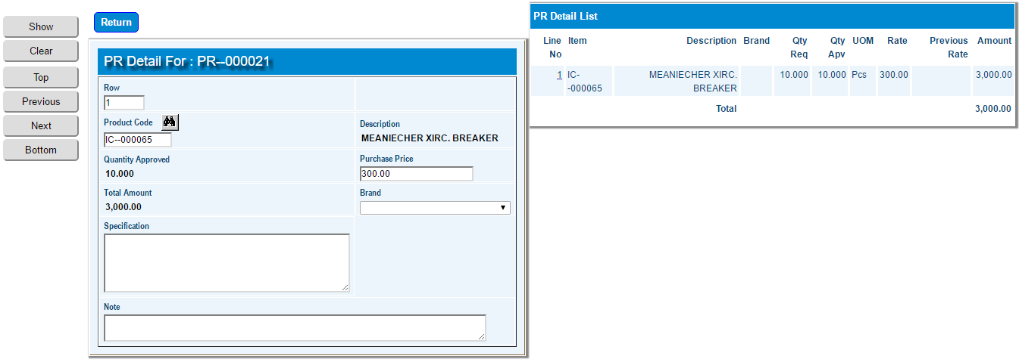

# Quotation entry

## Quotation Entry

|  |  |
| --- | --- |
| **Step 1** | Open System **>** Purchase **>** Quotation Entry |
| **Step 2** | Select PR from side list or write the no in the PR no field |
| **Step 3** | Click show |
| **Step 4** | Click Detail |
| **Step 5** | Select the desired Item from the Requisition Detail side list |
| **Step 6** | Click Quotation Entry |
| **Step 7** | Select specification, fill in the value for the specification in Quotation 1,2,3,4,5. |
| **Step 8** | Click Add |
| **Step 9** | Repeat Step 5 to 7 for adding multiple specification |
| **Result** | Quotation filled for Comparison Statement |

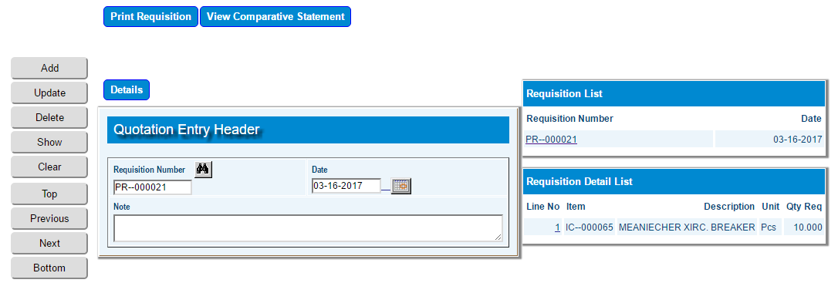

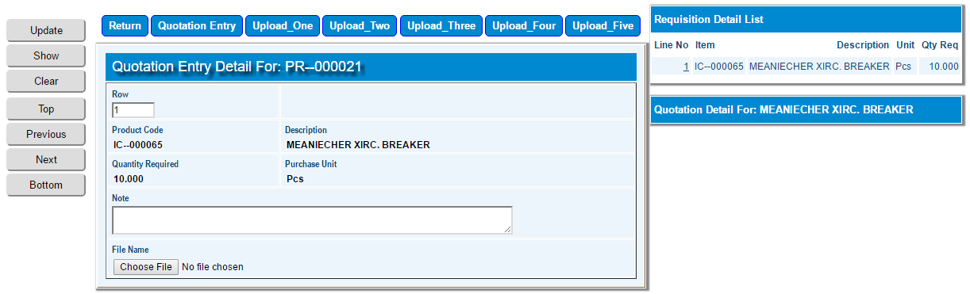

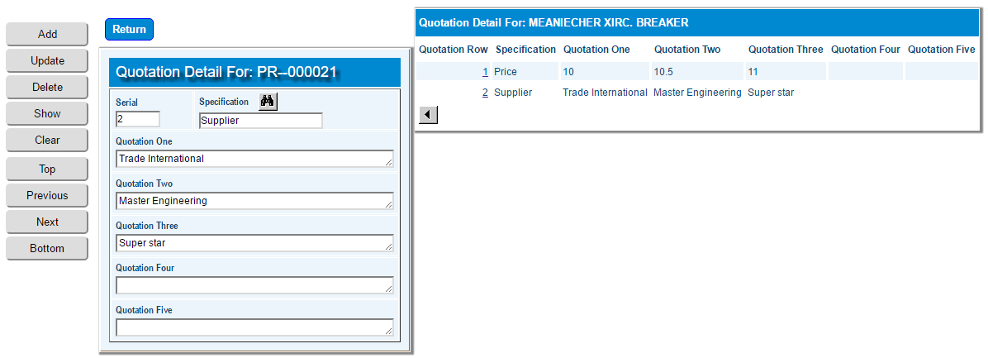

## Quotation Upload

|  |  |
| --- | --- |
| **Step 1** | Open System **>** Purchase **>** Quotation Entry |
| **Step 2** | Select PR from side list or write the no in the PR no field |
| **Step 3** | Click show |
| **Step 4** | Click Detail |
| **Step 5** | Click Chose File to choose the quotation image location. |
| **Step 6** | Click Upload_One, Two, Three, Four, Five |
| **Step 7** | Repeat Step 5 and 6 for uploading multiple Quotation |
| **Step 8** | Click Preview Comparative Statement for viewing the CS statement |
| **Result** | Quotation uploaded in the system |

# create Purchase order (po) from requisition

|  |  |
| --- | --- |
| **Step 1** | Open System **>** Purchase **>** Create PO From Requisition |
| **Step 2** | Select PR from side list or write the no in the PR no field |
| **Step 3** | Click show |
| **Step 4** | Fill in supplier Code |
| **Step 5** | Click Create_PO |
| **Result** | PO created |

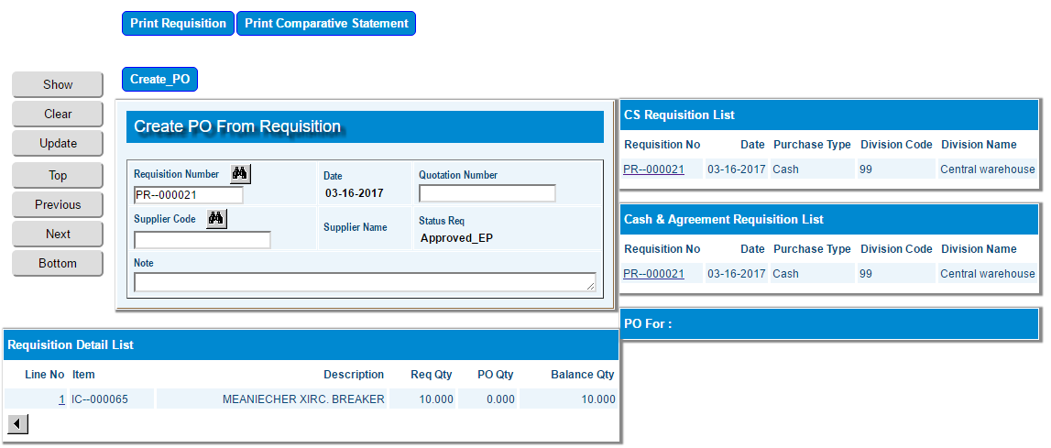

# ADMINISTRATION

## Define Role Name

|  |  |
| --- | --- |
| **Step 1** | Open System **>** Administration **>** Manage Users **>** Define Role Name |
| **Step 2** | Fill in role code |
| **Step 3** | Check Activate box |
| **Step 4** | Click Add |
| **Result** | New Role name created |

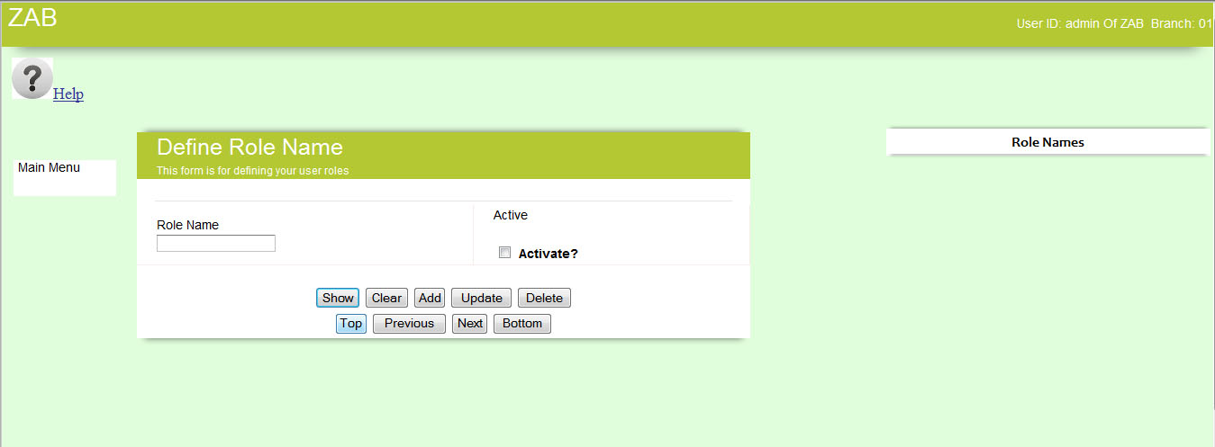

Manage Roles

|  |  |
| --- | --- |
| **Step 1** | Open System **>** Administration **>** Manage Users **>** Manage Roles |
| **Step 2** | Select role |
| **Step 3** | Fill in access code |
| **Step 4** | Check Activate box |
| **Step 5** | Click Add |
| **Result** | New role created |

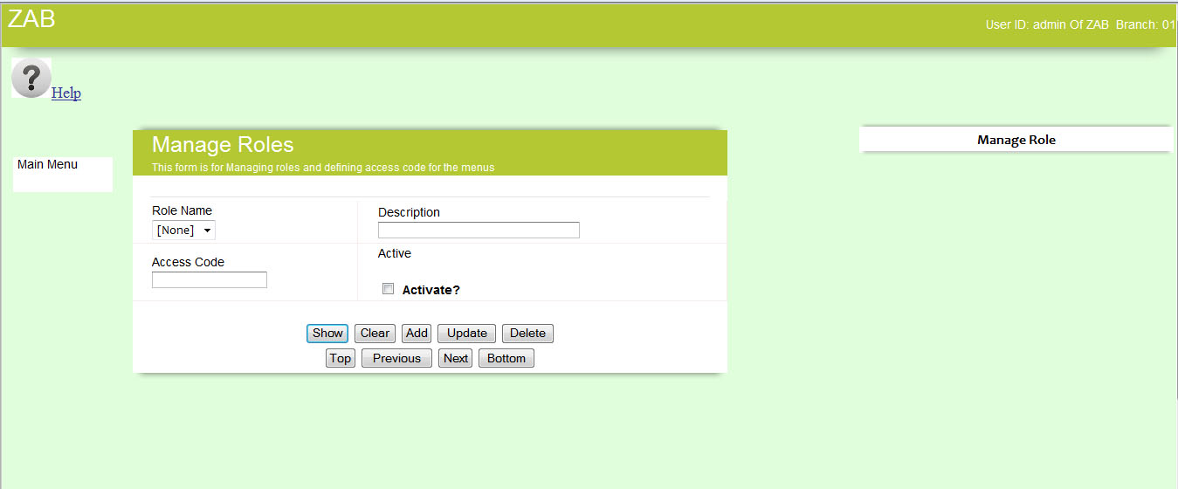

## Define Menu Access

|  |  |
| --- | --- |
| **Step 1** | Open System **>** Administration **>** Manage **>** Define Menu Access |
| **Step 2** | Select Menu & Option |
| **Step 3** | Define Access List code |
| **Step 4** | Check Activate box |
| **Step 5** | Click Add |
| **Result** | Access code defined for menus |

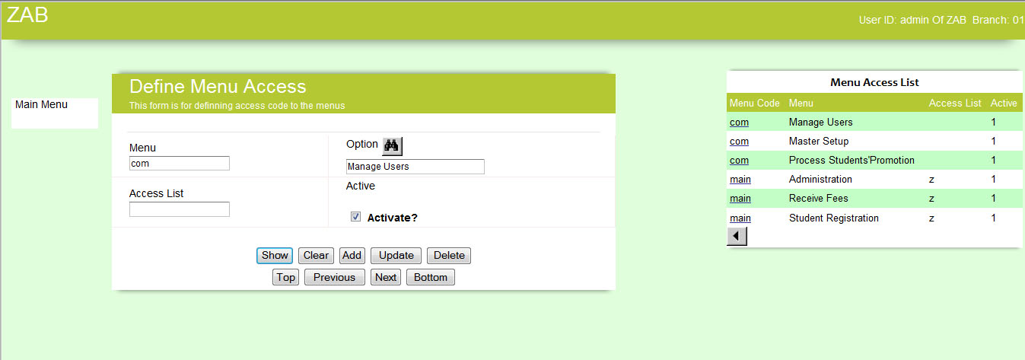

## Manage Users

|  |  |
| --- | --- |
| **Step 1** | Open System **>** Administration **>** ManageUsers **>** Manage Users |
| **Step 2** | Fill in user code |
| **Step 3** | Define access code for this user |
| **Step 4** | Check Activate box |
| **Step 5** | Click Add |
| **Result** | User created with access privilege |

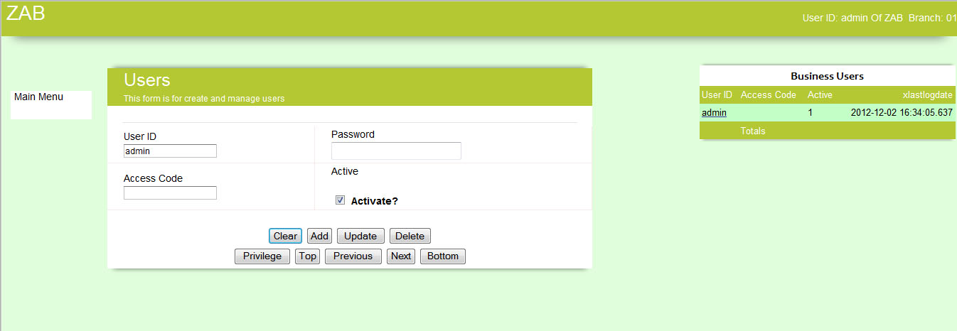

## Fees Process

|  |  |
| --- | --- |
| **Step 1** | Open System **>** Administration **>** Process Students’ Promotion |
| **Step 2** | Select class for promoted from and promoted to field |
| **Step 3** | Select student code for single process or left blank to process all the students |
| **Step 4** | Click Process |
| **Result** | Students promoted to the desired class |

## Student Promotion Process

|  |  |
| --- | --- |
| **Step 1** | Open System **>** Administration **>** Process Students’ Promotion |
| **Step 2** | Select class for promoted from and promoted to field |
| **Step 3** | Select student code for single process or left blank to process all the students |
| **Step 4** | Click Process |
| **Result** | Students promoted to the desired class |

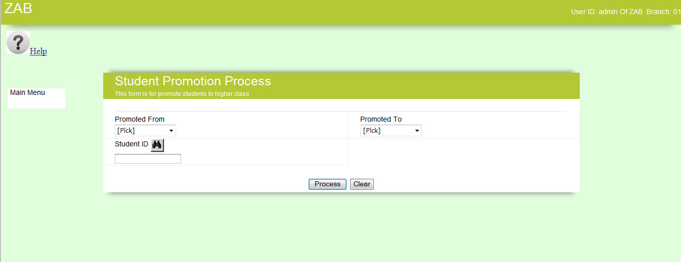

## Charge Code Entry

|  |  |
| --- | --- |
| **Step 1** | Open System **>** Administrator **>** Master Setup **>** Charge Code Entry |
| **Step 2** | Enter charge code, Description |
| **Step 3** | Check Activate box |
| **Step 4** | Click Add |
| **Result** | New Charge Code Added |

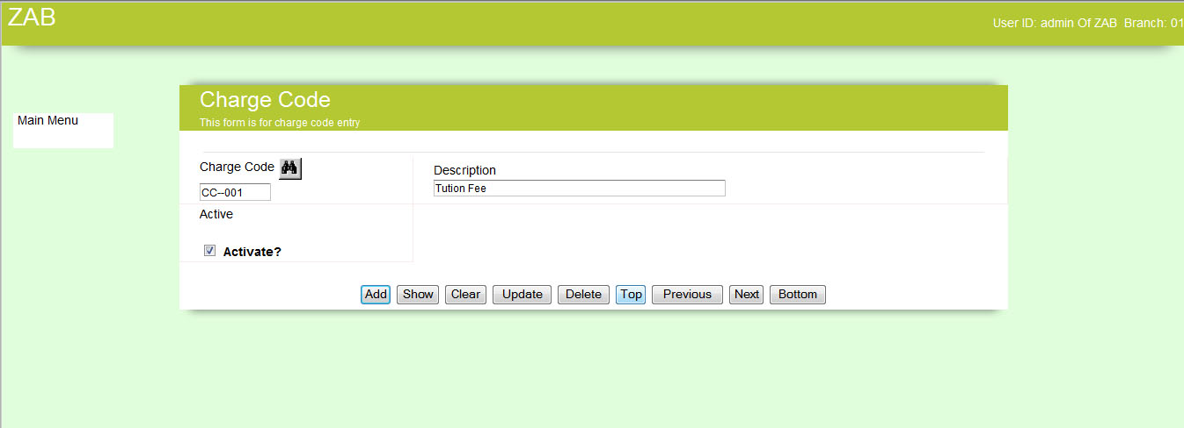

## Yearly Charge Setting

|  |  |
| --- | --- |
| **Step 1** | Open System **>** Administration **>** Master Setup **>** YearlyCharge Setting |
| **Step 2** | Enter desired year and select class from the drop down box |
| **Step 3** | Click Add then click Detail |
| **Step 4** | Select charge code from the list enter charge amount for that charge code |
| **Step 5** | Click Add |
| **Result** | New charge set for the defined year and class |

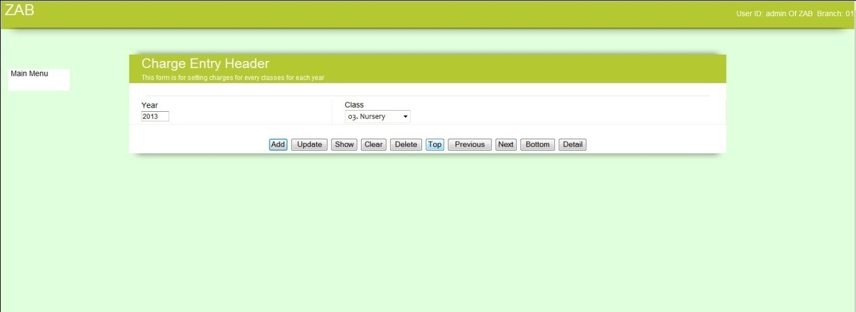

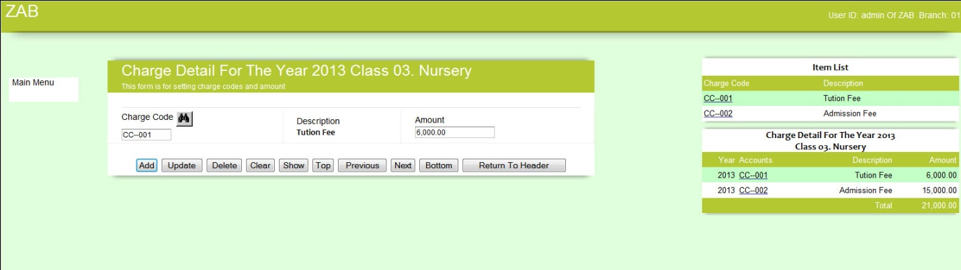

## Class Name Entry

|  |  |
| --- | --- |
| **Step 1** | Open System **>** Administration **>** Master Setup **>** Class Name Entry |
| **Step 2** | Enter class name |
| **Step 3** | Check Activate box |
| **Step 4** | Click Add |
| **Result** | New Charge Code Added |

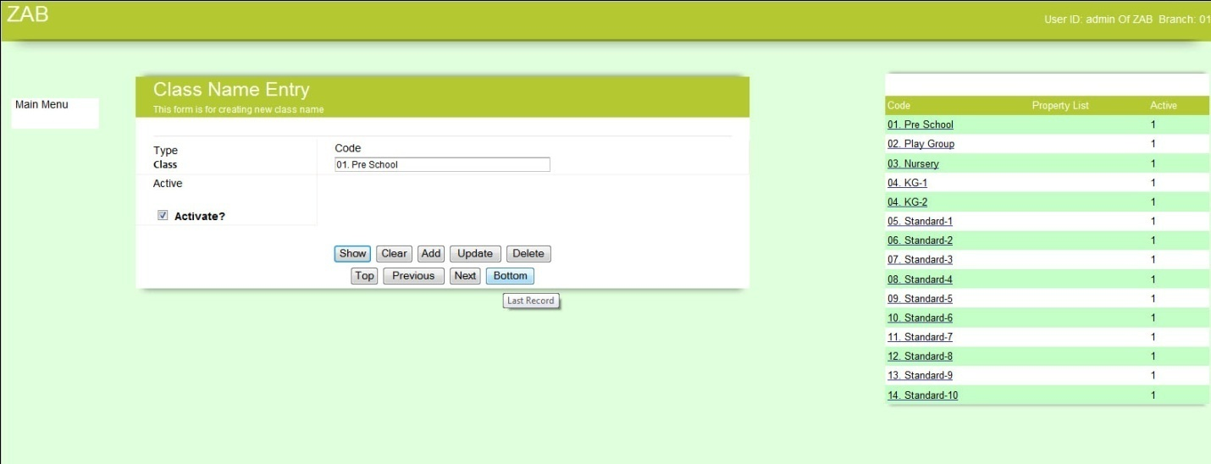

## Default Setup

|  |  |
| --- | --- |
| **Step 1** | Open System **>** Administration **>** Master Setup **>** Default Setup |
| **Step 2** | Fill in year, period and starting period in the period offset field for setup the session |
| **Step 3** | Fill in VAT rate, fine amount and date of each month from where the fine will be effective |
| **Step 4** | Click Add |
| **Result** | Default setting added |

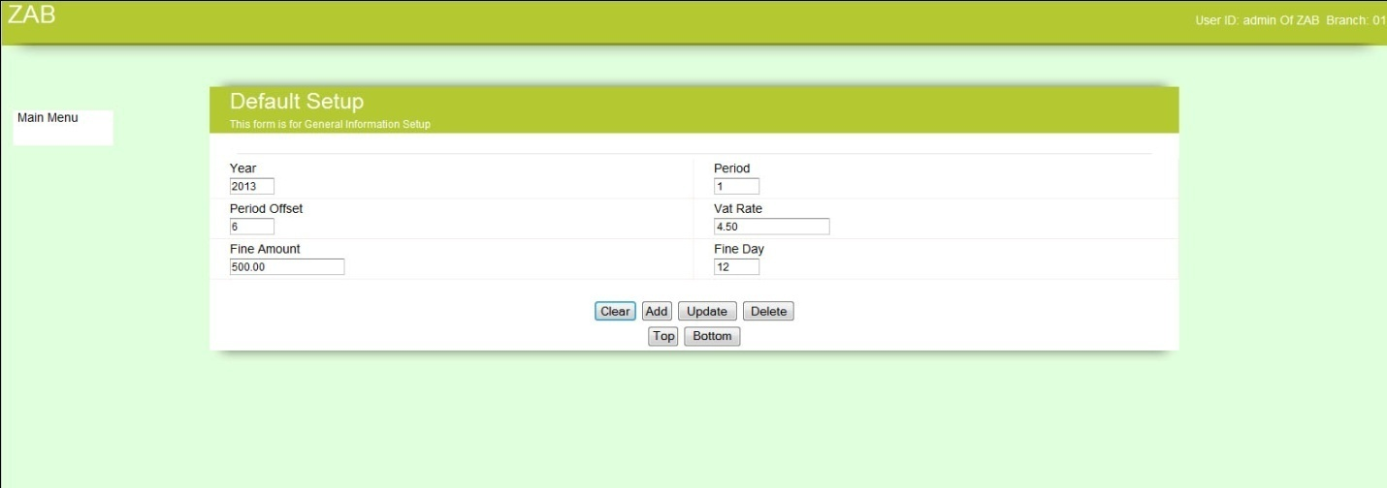

# Student registration

|  |  |
| --- | --- |
| **Step 1** | Open System **>** Student Registration |
| **Step 2** | Fill in Student name, Fathers Name and other information to complete the registration. Student ID will be generated automatically. |
| **Step 3** | Select Open, Closed, Transferred or Hold as status of the student |
| **Step 4** | Click Add |
| **Result** | Registration complete for a student |

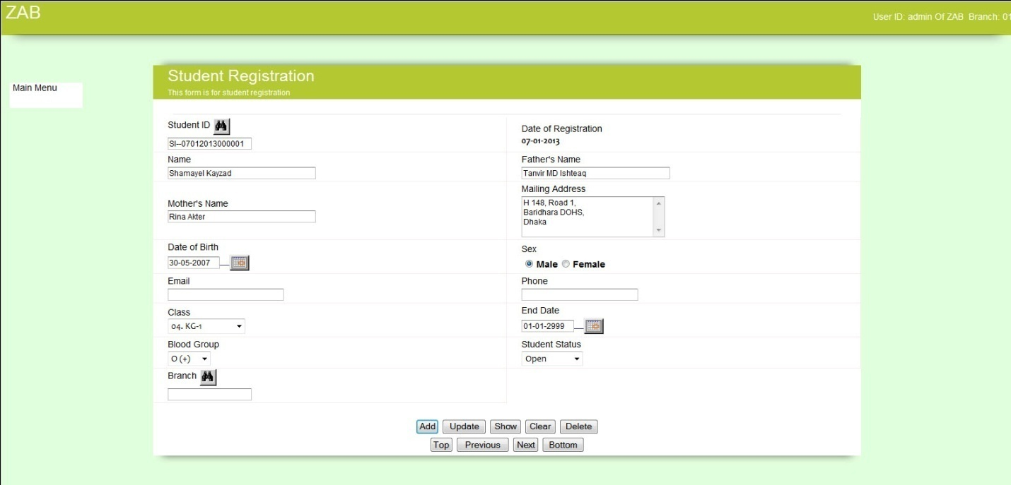

# Receive fees

|  |  |
| --- | --- |
| **Step 1** | Open System **>** Receive Fees |
| **Step 2** | Select student ID, MR No will be generated and fine will calculate automatically |
| **Step 3** | Click Add |
| **Step 4** | Click Detail > Detail screen will appear |
| **Step 5** | Select charge code and fill in number of charges. Amount will come automatically from the yearly charge setting. |
| **Step 6** | Click Add. (**You can add multiple charges in one Money Reciept**) |
| **Step 7** | Click Return to Header |
| **Step 8** | Fill in discount (Optional) and fill in paid amount. |
| **Step 9** | Click update. (change amount will appear automatically) |
| **Result** | Fees received from student. |

